**HOMAGE TO ARYA MISSIONARY K. VELAYUDHA ARYA (06 AUG 1930 – 12 MAY 2014)**

**By KM Rajan**

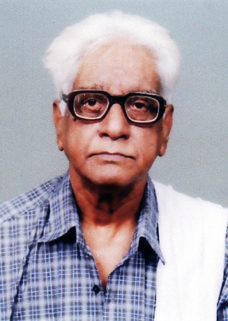

Veteran Arya Missionary K Velayudha Arya passed away at 3 pm on 12 May 2014 at his residence in Calicut (Kerala). The Anthyeshti Sanskar (cremation) will be held at 11 am on 13 May 2014 as per Vedic rites. With his death the entire Arya Jagat has lost a veteran Arya Missionary who devoted his entire life for the mission of Arya Samaj and Maharshi Dayanand’s ideals. He was a *stauch shudhi pracharak*  and actively participated in the Arya Samaj movement against Meenakshipuram (Tamil Nadu) mass conversion held in 1980s.

**Born on 06 Aug 1930**. Parent’s names: Poyilil Kuttan Nair and Kizhuvalathu Ammalu Amma.

**Education** : Intermediate in Art subjects (1949-51) Worked as clerk in Postal department (1953-1988) at Madras. After retirement from service settled at Kozhikkode district of Kerala.

**Arya Samaj Activities** : Became a member of Arya Samaj, Chennai and hold various organisational posts such as Asst General Secretary (in 1970) and Librarian from 1971-77. Assistant editor of ‘Veda Jyothi’ a Tamil monthly of Arya Samaj. Founded ‘Dayananda Mission’ with the support of like minded friends and was its Secretary from 1973-1986. Published numerous pamphlets and small books and translated many books of Swamy Dayananda into Tamil. Presently he is the Chief Editor of Dayananda Sandesam, the monthly Vedic Journal of Arya Samajam, Vellinezhi, Kerala

**Major Works**

1. Translated the Rig vedadi bhashya bhoomika into Tamil.

2. Yajurveda bhashyam of Swamy Dayanand into Tamil.

3. Vaidika Geetha.

4. Pune Lectures (Upadesha manjari) into Tamil.

5. Atharva veda manthra vidya of Swamy Brahma muni.

6. Atharva veda parichay of Pt Vishwanath Vidyamarthand.

7. Selections from Upanishads into Tamil.

8. He wrote a number of articles based on Vedas and translations from various Arya Samaj literatures. Presently he was doing the Malayalam translation of ‘*Quran parichay*’ (3 volumes of hindi book ‘Quran Parichay’ written by Acharya Dev Praksh) and writing a book on ‘Gandhiji, Muslims and Hindus (in Malayalam). He was also checking the proof of Malayalam version of famous Urdu book ‘*Rangeela Razool*’(written by great Vedic scholar late Pandit Chamupathi Ji) translated by a young Arya Missionary in Kerala.

May Paramathma give us strength to continue his mission. This will be the real tribute to the departed soul.