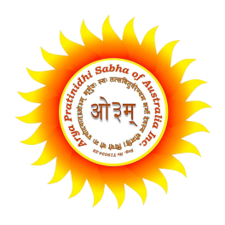

Arya Pratinidhi Sabha of Australia

69 Shane Park Road, Shanes Park N.S.W. 2747 Australia

**www.aryasamajaustralia.com.au**

International Arya MahaSammelan

27-28-29 November 2015

**Theme**: Significance of Vedas in contemporary world

**Suggested topic:**

1. Vedas – Divine knowledge?
2. Vedic Concept of God – Consistent, real-world and rational approach
3. Science in the Vedas
4. What Arya Samaj Stands for / Why Vedic Dharma
5. Vedas in Daily life
6. Health System in the Vedas
7. Science of reproduction as per Vedas – Bringing wise soul to our home
8. Vedic values to create noble family
9. Scientific aspects of Agnihotra and Mantra chanting
10. Rebirth & Karmic cycle – Vedic solution to reduce crime and for peace in society
11. Women status in Vedas

**Prospective Speakers**

1. Acharya Sanat Kumar Ji Vedacharya
2. Acharya Ashish ji Darshanacharya
3. Acharya Dr. Satish Prakash ji (New York, US)
4. Acharya Gyaneshwar ji Darshanacharya

Note: Our guest scholars will be supporting and preparing our Local youth members on different issues, who will be presenting some of the topics or sub topic listed above.

**Daily sessions**: Various Sessions starts from 9 a.m. to 8 p.m.

**Meal:** Vegetarian Lunch, Dinner and refreshments provided from Arya Samaj Kitchen.

**Registration requirements**: All Participants must have registration requirements completed prior to participating in any of sessions. Registration form can be downloaded from **www.aryasamajaustralia.com.au**